Lab 4: Performing Advanced Data Calculations

© 2024 Amazon Web Services, Inc. or its affiliates. All rights reserved. This work may not be reproduced or redistributed, in whole or in part, without prior written permission from Amazon Web Services, Inc. Commercial copying, lending, or selling is prohibited. All trademarks are the property of their owners.

Note: Do not include any personal, identifying, or confidential information into the lab environment. Information entered may be visible to others.

Corrections, feedback, or other questions? Contact us at [*AWS Training and Certification*](https://support.aws.amazon.com/#/contacts/aws-training).

**Lab overview**

You have created your first Amazon QuickSight dashboard. You’ve enhanced it, added some interactivity, and incorporated data from different data sources into it. AnyCompany Software has many customer segments, and you are responsible for defining and building key performance indicators (KPIs) in preparation for an upcoming shareholder meeting. You are investigating how you can use Amazon QuickSight to build accurate KPIs to represent the company’s performance.

In this lab, you use QuickSight to understand how KPI figures are calculated through additive and non-additive measures. You determine the right calculation methodology to use based on the requirements from your sales team, and you explore how level-aware calculation window functions work in QuickSight.

OBJECTIVES

By the end of this lab, you should be able to do the following:

* Create a KPI with an additive measure.
* Calculate a non-additive measure correctly.
* Create a level-aware calculation window function that interacts with filter choices.

DURATION

This lab requires approximately *45* minutes to complete.

ICON KEY

Various icons are used throughout this lab to call attention to different types of instructions and notes. The following list explains the purpose for each icon:

* **Expected output:** A sample output that you can use to verify the output of a command or edited file.
* **Note:** A hint, tip, or important guidance.
* **Learn more:** Where to find more information.
* **Caution:** Information of special interest or importance (not so important to cause problems with the equipment or data if you miss it, but it could result in the need to repeat certain steps).
* **Consider:** A moment to pause to consider how you might apply a concept in your own environment or to initiate a conversation about the topic at hand.
* **Hint:** A hint to a question or challenge.
* **Answer:** An answer to a question or challenge.
* **Task complete:** A conclusion or summary point in the lab.

**Start lab**

1. To launch the lab, at the top of the page, choose Start lab.

**Caution:** You must wait for the provisioned AWS services to be ready before you can continue.

1. To open the lab, choose Open Console.

You are automatically signed in to the AWS Management Console in a new web browser tab.

**WARNING:** **Do not change the Region unless instructed.**

COMMON SIGN-IN ERRORS

**Error: You must first sign out**

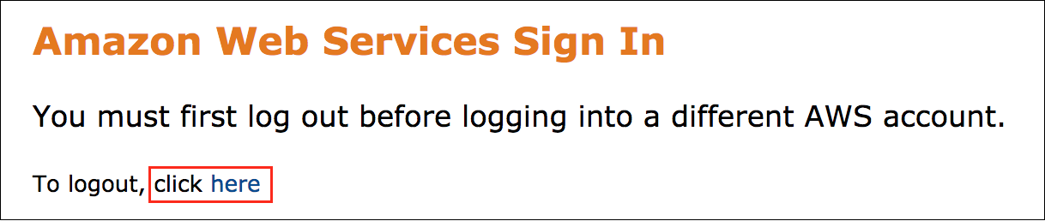

If you see the message, **You must first log out before logging into a different AWS account:**

* Choose the **click here** link.
* Close your **Amazon Web Services Sign In** web browser tab and return to your initial lab page.
* Choose Open Console again.

**Error: Choosing Start Lab has no effect**

In some cases, certain pop-up or script blocker web browser extensions might prevent the **Start Lab** button from working as intended. If you experience an issue starting the lab:

* Add the lab domain name to your pop-up or script blocker’s allow list or turn it off.
* Refresh the page and try again.

AWS SERVICES NOT USED IN THIS LAB

AWS service capabilities used in this lab are limited to what the lab requires. Expect errors when accessing other services or performing actions beyond those provided in this lab guide.

**Task 1: Calculate an additive measure**

Your sales team wants a cost KPI created from the sales and profit fields. Cost is an additive measure (a calculation that can be aggregated several times). You calculate cost by using row and aggregate calculations to determine how to correctly calculate the field.

In this task, you create two calculated fields. You then compare the fields in a table to confirm the correct calculation method to use for the KPI.

TASK 1.1: CALCULATE COST FROM SALES AND PROFIT

Add two calculated fields for cost, one at the row level and one at the aggregate level.

1. At the top of the **AWS Management Console**, in the search bar, search for and choose

.

1. From the **Analyses** page, choose **quicksight-lab-4**.
2. In the top menu bar, choose **Insert**.
3. Choose **Add calculated field**.
4. For **Add name**, enter

.

1. In the calculation workspace, enter

.

1. Choose **Save**.
2. In the top menu bar, choose **Insert**.
3. Choose **Add calculated field**.
4. For **Add name**, enter

.

1. In the calculation workspace, enter

.

1. Choose **Save**.

**Expected output:** You now have two calculated fields for cost. The *Row Cost* field is calculated row by row, and the *Aggregate Cost* field is calculated by the sum of all sales subtracted by the sum of all profit.

**Consider:** Before moving on, predict if these calculations will be the same or different in a table.

TASK 1.2: CREATE A TABLE TO COMPARE THE CALCULATIONS

Now that you have two calculated fields, create a table to compare the calculations and see if they are equivalent.

1. To create a new sheet, in the dashboard workspace next to the **Details** tab, choose the plus sign **+**.
2. Verify that **Interactive sheet** is selected, and then choose **Add**.
3. To rename the sheet, choose the **Sheet 2** tab, and then enter

.

1. Choose the autograph and in the **Visual types** pane, find and choose the **Table** icon.
2. In the **Fields list** pane, choose **Segment**, **Profit**, **Sales**, **Row Cost**, and **Aggregate Cost**.

**Caution:** You might need to expand the **Metrics** folder to see the *Profit* and *Sales* fields. You can also enter any field name into **Search fields**.

1. In the visualization menu on the right of your table, choose the **Menu options** ellipsis icon, and then choose **Show totals**.

**Expected output:** For an additive measure, the results are equivalent for row and aggregate calculations.

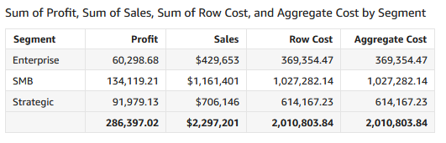

*Image description: The preceding image shows the additive measures table*.

**Note:** Because the *Cost* field is additive, both row-level calculations and aggregate-level calculations give the same result. In such cases, use the row-level version. Include it in the dataset layer to have the row-level calculation done ahead of time with the SPICE dataset refresh.

**Task complete:** You have completed **Task 1** by calculating an additive measure. You created two cost calculations and compared them in a table.

**Task 2: Calculate a non-additive measure**

Your sales team also needs a profit margin KPI from the sales and profit fields. Profit margin is a non-additive measure (a calculation that would produce an incorrect result if it was aggregated). You calculate profit margin by using row and aggregate calculations to determine how to correctly calculate the field.

In this task, you create two calculated fields. You then compare the fields in a table to confirm the correct calculation method to use for the KPI.

CHALLENGE A: CALCULATE PROFIT MARGIN FROM SALES AND PROFIT

Add two calculated fields for profit margin, one at the row level and one at the aggregate level.

**Hint:** Calculate profit margin by dividing profit by sales.

**Hint:** For help completing this challenge task, see the [**Challenge A solution**](https://us-east-1.durian.bkr.team.aws.training/session/rECSndMc81PW4vvcwZNuaY?locale=en-US&reference=sCm4f4gcixZqMUgXPoUz5y%3A%3A7759f935-0c5f-4c9f-a8d1-ce89471a7323#lab_4_challenge_a).

CHALLENGE B: CREATE A TABLE TO COMPARE THE CALCULATIONS

Now that you have two calculated fields, you want to create a table to compare the calculations and see if they are equivalent.

**Hint:** For help completing this challenge task, see the [**Challenge B solution**](https://us-east-1.durian.bkr.team.aws.training/session/rECSndMc81PW4vvcwZNuaY?locale=en-US&reference=sCm4f4gcixZqMUgXPoUz5y%3A%3A7759f935-0c5f-4c9f-a8d1-ce89471a7323#lab_4_challenge_b).

**Task complete:** You have completed **Task 2** by calculating a non-additive measure. You created two profit margin calculations and compared them in a table.

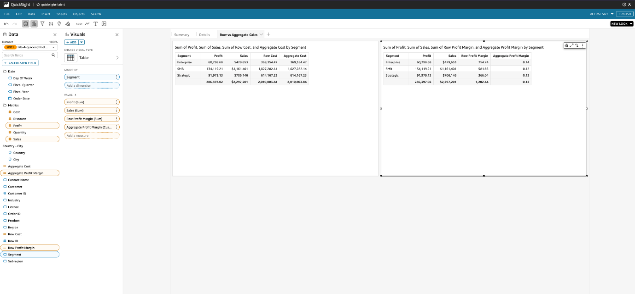

*Image description: The preceding image shows the dashboard*.

**Task 3: Create level-aware calculation window functions**

Now that you have calculated the fields for cost and profit margin, you want to create additional sales fields that will respond to different kinds of filters. These level-aware calculation window functions will ensure accurate reporting in your sales KPIs.

In this task, you create two calculated fields that respond to filters in different ways. You then test the results returned to the dashboard.

TASK 3.1: ADD TWO CALCULATED FIELDS

Add two calculated fields by using the PRE_FILTER and PRE_AGG keywords. You use these fields to create several KPIs.

**Learn more:** In QuickSight, PRE_FILTER calculations are evaluated before applying filters from the analysis, and PRE_AGG calculations are evaluated before computing display-level aggregations such as Top 10 filters.

1. In the top menu bar, choose **Insert**.
2. Choose **Add calculated field**.
3. For **Add name**, enter

.

1. In the calculation workspace, enter

.

1. Choose **Save**.
2. Repeat the same steps to add an

 field with a calculation of

.

**Expected output:** You now have two calculated fields for sales that are level-aware.

**Learn more:** QuickSight has many features you can use when designing custom calculations. For more information about level-aware calculation window functions and other QuickSight calculations, see [Using level-aware calculations in Amazon QuickSight](https://docs.aws.amazon.com/quicksight/latest/user/level-aware-aggregations.html) in the *Amazon QuickSight User Guide*.

TASK 3.2: CREATE A TABLE TO COMPARE THE LEVEL-AWARE CALCULATION WINDOW FUNCTIONS

You want to create a new tab and table to test the different calculations. You’ll decide which ones should be used for your new sales KPIs, paying close attention to how they respond to filters so that you can label the KPIs correctly.

1. To create a new sheet, in the dashboard workspace next to the **Row vs Aggregate Calcs** tab, choose the plus sign **+**.
2. Verify that **Interactive sheet** is selected, and then choose **Add**.
3. To rename the sheet, choose the **Sheet 3** tab, and then enter

.

1. In the **Visual types** pane, find and choose the **Table** icon.
2. In the **Fields list** pane, choose **Industry**, **Sales**, **Overall Sales [PRE_FILTER]**, and **Overall Sales [PRE_AGG]**.
3. In the visualization menu on the right of your table, choose the **Menu options** ellipsis icon, and then choose **Show totals**.

**Expected output:** All three fields show the same results across the full dataset. Next, you add different filters to demonstrate how each keyword affects the calculations.

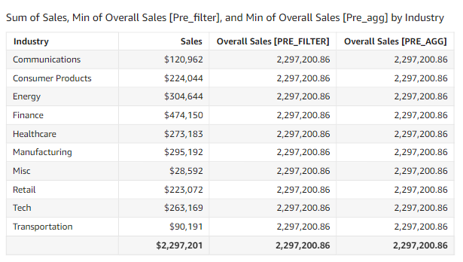

*Image description: The preceding image shows the level-aware calculations table*.

TASK 3.3: ADD A FILTER TO COMPARE THE RESULTS

Test the difference between PRE_FILTER and PRE_AGG by creating and applying a filter to the table.

1. In the **Level-Aware Calculations** industry table, choose the **Sales** column header, and then choose the second **Sort by** option to sort in **Descending** order. This puts the largest orders at the top of the table.
2. In the **Fields list** pane, choose the ellipsis icon next to **Industry**.
3. Choose **Add filter for this field**.
4. In the **Filters** pane, choose the ellipsis icon next to the **Industry** filter, and then choose **Add to sheet**.

**Note:** You can resize the filter by selecting and dragging any of the white squares at the corners or edges of the filter.

1. In the **Industry** filter, choose **All** to open the dropdown list, and then clear **Misc**.

**Expected output:** The *Overall Sales [PRE_FILTER]* calculation stays the same, but the *Sales* and *Overall Sales [PRE_AGG]* calculation change, omitting the *Misc* industry from the aggregation.

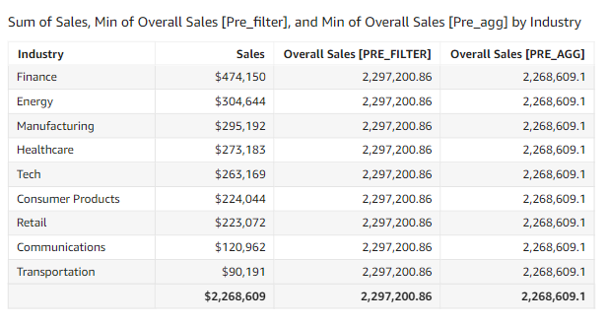

*Image description: The preceding image shows the level-aware calculations table with filters applied*.

TASK 3.4: ADD A TOP 5 FILTER

Use a Top 5 aggregated filter to change the value shown in the POST_AGG_FILTER field.

1. Choose the **Level-Aware Calculations** industry table.
2. In the navigation pane at the top of the screen, choose the **FILTER** icon.
3. Choose **+ ADD** and choose **Industry** from the list.
4. To expand the filter options, in the **Filters** pane, choose the newly created **Industry** filter (with the **Include - all** subtitle).
5. Choose **Filter list**, and then choose **Top and bottom filter**.
6. For **Show top**, enter

 in the Integer.

1. For **By**, choose **Sales**.

**Caution:** You might need to expand the **Metrics** folder to see the *Sales* field. After you’ve selected **Sales**, you can choose **Sales (Sum)** in the **By** section to close the dropdown list.

1. Choose **APPLY**.

**Expected output:** The *Overall Sales [PRE_FILTER]* and *Overall Sales [PRE_AGG]* calculations stayed the same as their prior values. The *Sales* calculation changed, however, only including the sales from the top five industries.

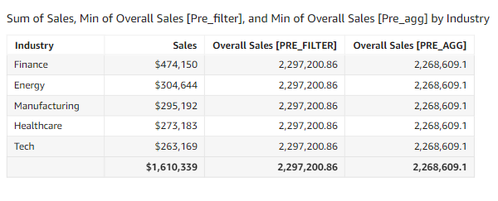

*Image description: The preceding image shows the level-aware calculations table with a Top 5 filter applied*.

**Consider:** Take a moment to consider which fields you would use for different KPIs. Which field would you use to show all sales, even when filters and aggregations are applied to the data?

As a summary, here are the valid fields you have created and how they were calculated:

| **Field** | **Calculation** |
| --- | --- |
| Row Cost | {Sales} - {Profit} |
| Aggregate Profit Margin | sum({Profit})/sum({Sales}) |
| Sales | {Sales} |
| Overall Sales [PRE_FILTER] | sumOver(Sales, [], PRE_FILTER) |
| Overall Sales [PRE_AGG] | sumOver(Sales, [], PRE_AGG) |

**Task complete:** You have completed **Task 3** by calculating level-aware calculation window functions. You created two new functions and tested how they respond to different filters and aggregations.

**Task 4: Add KPIs to the summary dashboard**

Your sales team wants you to add three KPIs to the Summary dashboard. They want to see KPIs for total sales, filter-responsive sales, and filter-responsive profit margin.

TASK 4.1: ADD A TOTAL SALES KPI

Add a total sales KPI to the Summary dashboard.

1. To return to the Summary dashboard for sales, in the dashboard workspace, choose the **Summary** tab.
2. In the navigation pane, choose **Visualize**.
3. Choose the arrow next to **+ Add**.
4. In the **Visuals** pane, find and choose the **Key Performance Indicator (KPI)** icon.
5. In the **Fields list** pane, choose **Overall Sales [PRE_FILTER]**.
6. In the **Value** section, choose the ellipsis icon next to **Overall Sales [PRE_FILTER] (Min)**.
7. To change the format to currency, hover over **Show as: Number** and choose **Currency**.
8. In the **Value** section, choose the ellipsis icon next to **Overall Sales [PRE_FILTER] (Min)**.
9. Hover over **Format: $1,234.57** and choose **More formatting options…**.
10. From the options that appear to the left, choose **Decimal places** to expand it, and enter

.

1. In the visualization menu on the right of your KPI visualization, choose the **Format visual** pencil icon to open the **Properties** pane.
2. In the **Format visual** pane, choose **Display Settings**, and then choose the paint brush icon next to **Edit title**.
3. In the **Default** section, enter

.

1. Choose **Save**.

**Expected output:** You now have a total sales KPI that is not impacted by any filter selections.

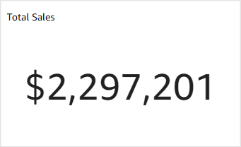

*Image description: The preceding image shows the total sales KPI*.

TASK 4.2: ADD A FILTER-RESPONSIVE SALES KPI

Add a filter-responsive sales KPI to the Summary dashboard.

1. To return to the Visuals column, in the **Format data** column, choose the back arrow.
2. Choose the arrow next to **+ Add**.
3. In the **Visual types** pane, find and choose the **Key Performance Indicator (KPI)** icon.
4. In the **Fields list** pane, choose **Sales**.
5. In the visualization menu on the right of your KPI visualization, choose the **Format visual** pencil icon to open the **Properties** pane.
6. In the **Format visual** pane, choose **Display Settings**, and then choose the paint brush next to **Edit title**.
7. In the **Default** section, enter

.

1. Choose **Save**.
2. In the dashboard workspace, on the **Industry** donut chart, choose an industry to see the KPI calculation adjust based on your selection.

**Expected output:** The *Total Sales* visualization stays the same, but the *Filtered Sales* visualization now shows the total sales for the industry you selected.

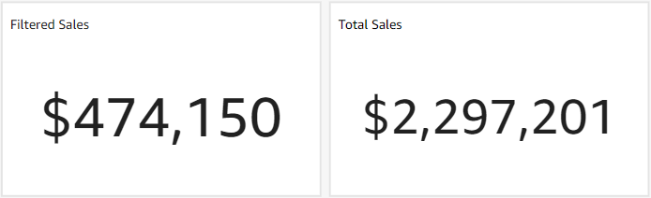

*Image description: The preceding image shows the filtered sales and total sales KPIs*.

CHALLENGE C: ADD A FILTER-RESPONSIVE PROFIT MARGIN KPI

Add a filter-responsive profit margin KPI to the Summary dashboard and resize the visuals to fit nicely in the dashboard.

**Hint:** For help completing this challenge task, see the [**Challenge C solution**](https://us-east-1.durian.bkr.team.aws.training/session/rECSndMc81PW4vvcwZNuaY?locale=en-US&reference=sCm4f4gcixZqMUgXPoUz5y%3A%3A7759f935-0c5f-4c9f-a8d1-ce89471a7323#lab_4_challenge_c).

**Task complete:** You have completed **Task 4** by adding KPIs to the dashboard. You created filter-aware KPIs and organized them on your dashboard.

**Conclusion**

**Task complete:** You used QuickSight to understand how KPI figures are calculated through additive and non-additive measures. You determined the right calculation methodology to use based on the requirements from your sales team. You also explored how level-aware calculation window functions work in QuickSight.

You have successfully done the following:

* Created a KPI with an additive measure
* Calculated a non-additive measure correctly
* Created a level-aware calculation window function that interacts with filter choices

**End lab**

Follow these steps to close out the console and end your lab.

1. At the upper-right corner of the QuickSight console, choose the user icon and then choose **Sign out**.
2. On this screen, choose **End lab** and then confirm that you want to end your lab.

**Appendix**

CHALLENGE A SOLUTION

**Answer:** To complete this challenge, you add two calculated fields for profit margin, one at the row level and one at the aggregate level.

1. In the top menu bar, choose **Insert**.
2. Choose **Add calculated field**.
3. For **Add name**, enter

.

1. In the calculation workspace, enter

.

1. Choose **Save**.
2. In the top menu bar, choose **Insert**.
3. Choose **Add calculated field**.
4. For **Add name**, enter

.

1. In the calculation workspace, enter

.

1. Choose **Save**.

**Expected output:** You now have two calculated fields for profit margin. The *Row Profit Margin* field is calculated row by row, and the *Aggregate Profit Margin* field is calculated by the sum of all profit divided by the sum of all sales.

**Consider:** Before moving on, predict if these calculations will be the same or different.

To continue this lab, move on to [Challenge B](https://us-east-1.durian.bkr.team.aws.training/session/rECSndMc81PW4vvcwZNuaY?locale=en-US&reference=sCm4f4gcixZqMUgXPoUz5y%3A%3A7759f935-0c5f-4c9f-a8d1-ce89471a7323#lab_4_task2-continue).

CHALLENGE B SOLUTION

**Answer:** To complete this challenge, you create a table to compare the calculations and see if they are equivalent.

1. In the **Visuals** column, choose the arrow next to **+ ADD**.
2. In the **Visual types** pane, find and choose the **Table** icon.
3. In the **Fields list** pane, select **Segment**, **Profit**, **Sales**, **Row Profit Margin**, and **Aggregate Profit Margin**.
4. In the visualization menu on the right of your table, choose the **Menu options** ellipsis icon, and then choose **Show totals**.

**Expected output:** For a non-additive measure, the results are not equivalent for row and aggregate calculations.

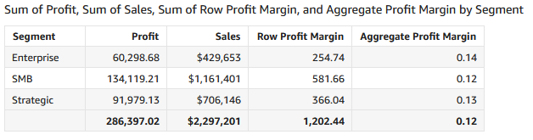

*Image description: The preceding image shows the non-additive measures table*.

**Note:** Because the profit margin field is non-additive, the row-level calculations and aggregate-level calculations give different results. The row calculation is happening at the data row level and is summed up like a regular aggregate measure. When reported in an aggregate form, the calculation ends up being incorrect at the segment level and overall total level. The aggregate-level calculation gives the correct results by summing the profit and sales before doing the division. Non-additive calculations like this need to be built as calculated fields that are calculated after a SPICE dataset refresh.

To continue this lab, move on to [Task 3.1](https://us-east-1.durian.bkr.team.aws.training/session/rECSndMc81PW4vvcwZNuaY?locale=en-US&reference=sCm4f4gcixZqMUgXPoUz5y%3A%3A7759f935-0c5f-4c9f-a8d1-ce89471a7323#lab_4_task3-continue).

CHALLENGE C SOLUTION

**Answer:** To complete this challenge, you add the filter-responsive profit margin KPI to the summary dashboard and resize the visuals to fit nicely in the dashboard.

1. In the **Visuals** column, choose the arrow next to **+ ADD**.
2. In the **Visual types** pane, find and choose the **Key Performance Indicator (KPI)** icon.
3. In the **Fields list** pane, select **Aggregate Profit Margin**.
4. In the visualization menu on the right of your KPI visualization, choose the **Format visual** pencil icon to open the **Properties** pane.
5. In the **Properties** pane, choose **Display Settings**, and then choose the paint brush next to **Edit title**.
6. In the **Default** section, enter

.

1. Choose **Save**.
2. Take a moment to move the KPIs around. Here is a sample of what an organized dashboard might look like:

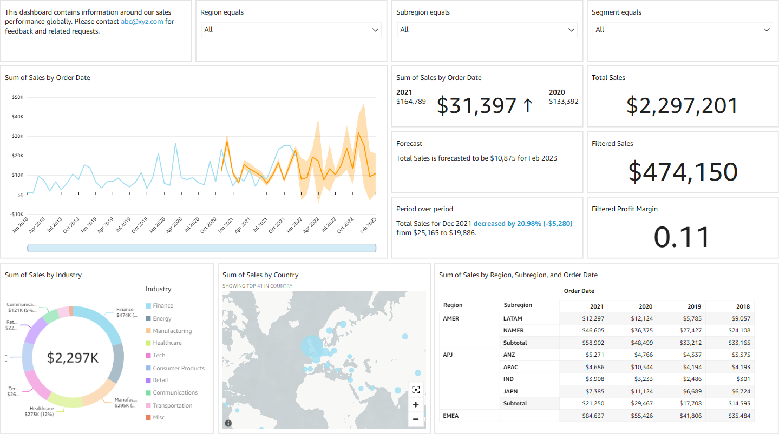

*Image description: The preceding image shows the dashboard*.

**Expected output:** You now have three new KPIs on your Summary dashboard that will help the sales team study the differences between industries and regions.

**Consider:** Take a moment to see how changing the **Segment**, **Region**, and **Subregion** filters affects the KPI results.

To continue this lab, move on to the [Conclusion](https://us-east-1.durian.bkr.team.aws.training/session/rECSndMc81PW4vvcwZNuaY?locale=en-US&reference=sCm4f4gcixZqMUgXPoUz5y%3A%3A7759f935-0c5f-4c9f-a8d1-ce89471a7323#lab_4_conclusion-continue).